Smart Campus Canteen: How Pre-Order Systems Reduce Waiting Time Using Slot Algorithms

1. Introduction
Every college student is familiar with the lunch break rush. The moment the bell rings, hundreds of students head toward the canteen, forming long queues that stretch across corridors. What should be a relaxing 30-minute break often turns into 20 minutes of standing in line and 5 minutes of hurried eating. Some students miss parts of their next class. Others skip meals altogether to avoid the chaos.
Despite campuses adopting digital learning tools and smart classrooms, many canteens still rely on manual ordering systems. Orders are shouted across counters, tokens are misplaced, and staff struggle to manage the sudden surge of demand. The issue is not the food itself — it is the lack of structured scheduling.
This article demonstrates how computing principles can transform traditional campus canteens into smart, efficient, and queue-free systems through a slot-based pre-order mechanism.
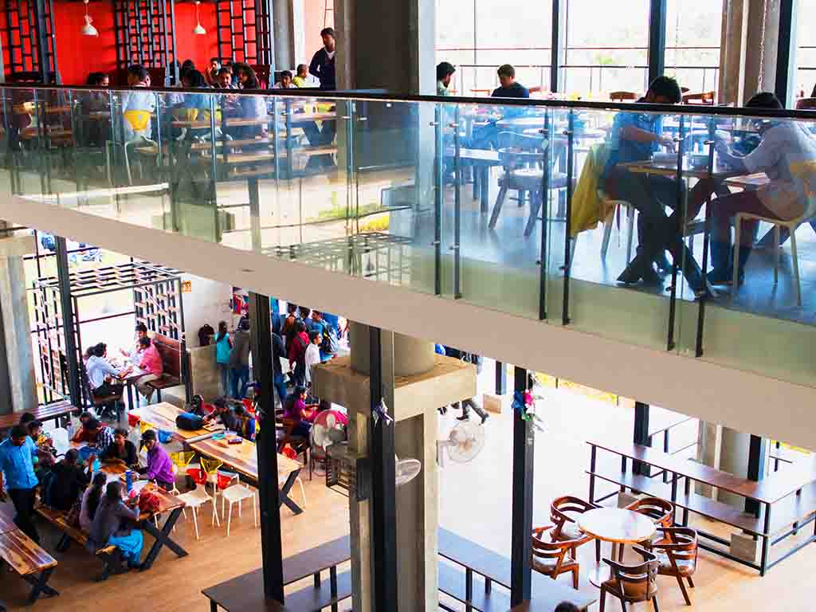

2. Problem Analysis: The Queue Crisis
At first glance, long queues may seem like a minor inconvenience. However, when examined closely, they reveal deeper operational inefficiencies.
Student Problems
Students typically have limited lunch breaks. Spending 20–30 minutes in line reduces eating time and increases stress. Some students skip meals to avoid delays. Others arrive late to lectures, affecting academic performance. Over time, this daily frustration lowers overall campus experience.
Canteen Problems
From the canteen’s perspective, demand is unpredictable. A sudden rush overwhelms kitchen staff, leading to order confusion and delayed preparation. Popular items may run out unexpectedly, while less demanded items may go to waste. Staff members must manually track orders, increasing the chances of errors.
System Problems
Traditional token systems lack real-time tracking. There is no way to monitor how many orders are pending or how much capacity the kitchen can handle at a specific time. There is no demand forecasting or digital record. The result is overcrowding during peak hours and underutilization during off-peak periods.
Clearly, the problem is not about food production — it is about scheduling and resource management. We need a digital solution.

3. Proposed Solution: Smart Pre-Order System
The proposed solution is a Smart Campus Canteen system built on a pre-order and slot-booking model.
Instead of physically standing in line, students use a mobile application or web portal. The process is simple:
- The student logs into the system.
- They browse the digital menu with real-time availability.
- They select a preferred pickup time slot (for example, 12:30–12:40 PM).
- They place the order.
- Payment is completed online.
- At the selected time, they collect the food directly from a dedicated pickup counter.
This approach distributes demand across multiple time intervals rather than concentrating it into a single chaotic rush. The kitchen receives advance information about upcoming orders, allowing them to prepare food systematically.
Instead of reacting to crowds, the system proactively manages demand. Students no longer compete for space in a queue. They simply arrive at their chosen time and collect their order. What used to be crowd-driven service becomes schedule-driven service.
In simple terms, queues are not a food problem — they are a scheduling problem that computing can solve.

4. System Architecture (Technical Core)
Behind this seemingly simple experience lies a structured computing architecture.
Frontend
The frontend consists of a mobile app or web portal. It provides an intuitive interface where students can view menus, select slots, place orders, and track status. The design must be user-friendly to ensure accessibility for all students.
Backend
The backend is the brain of the system. It handles:
- User authentication (using secure mechanisms such as JWT)
- Order processing
- Slot allocation logic
- Payment verification
- Status updates
When a student selects a slot, the backend checks availability in real time before confirming the booking.
Database
A structured database stores essential information:
- User profiles
- Menu items and pricing
- Orders and payment status
- Slot capacity and booking counts
This ensures reliable tracking and data consistency.
Cloud Deployment
Hosting the system on cloud infrastructure ensures scalability. During peak hours, the system can handle hundreds of simultaneous users without crashing. Cloud deployment also enables centralized management and data backup.
Together, these components form a connected ecosystem where frontend, backend, and database communicate seamlessly to deliver an efficient experience.

5. The Slot Algorithm (Innovation Core)
The core innovation of the system lies in the slot-limiting algorithm.
Consider this example:
- Time Slot: 12:30–12:40 PM
- Maximum Orders Allowed: 20
The system follows three simple logical steps:
- Count how many orders are already booked for the selected slot.
- If the count is less than 20, allow booking.
- If the count reaches 20, automatically disable the slot.
This algorithm ensures that kitchen capacity is never exceeded. It prevents 100 students from arriving at the same time. Instead, students are evenly distributed across multiple slots.
Why does this work?
- It prevents staff overload.
- It controls crowd density.
- It ensures food is freshly prepared for a manageable number of orders.
- It guarantees faster pickup.
This is a practical example of algorithmic thinking applied to everyday life. A simple counting logic creates a powerful impact on operational efficiency.

6. Real-World Impact
The implementation of such a system benefits multiple stakeholders.
For Students
- No waiting in long queues.
- Better time management.
- Reduced stress during lunch breaks.
- More time to relax or socialize.
For Canteen Management
- Predictable demand forecasting.
- Structured food preparation.
- Reduced food wastage.
- Improved staff efficiency.
For the College
- Promotes a smart campus initiative.
- Encourages digital transformation.
- Demonstrates practical implementation of computing solutions.
Small digital interventions can significantly enhance campus life.

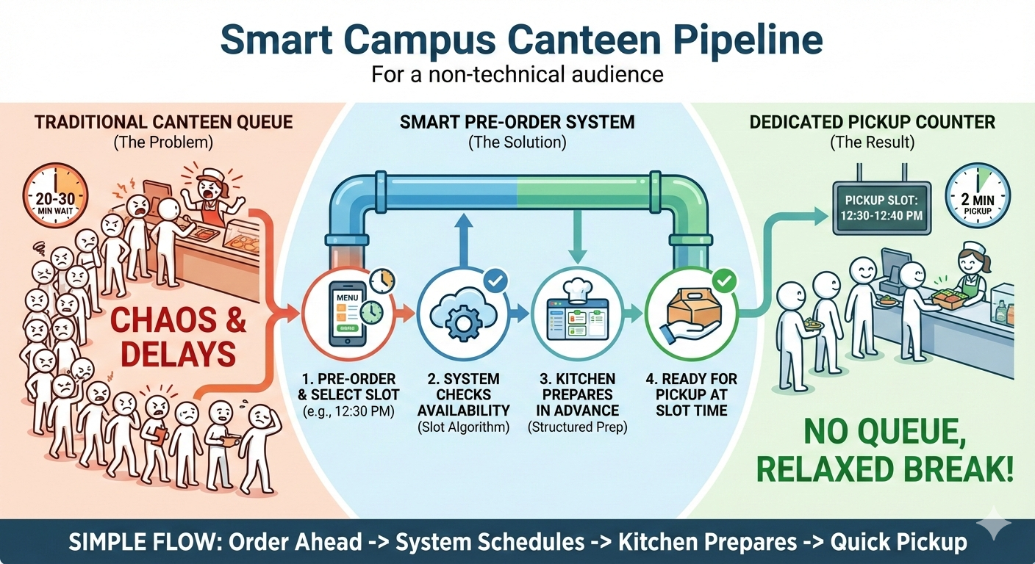

7. Future Enhancements
The system can be further improved using advanced technologies.
- AI-based demand prediction to forecast peak hours.
- Personalized food recommendations based on past orders.
- Smart inventory management to automatically update stock.
- Integration with campus ID cards for a cashless ecosystem.
- Administrative dashboards with analytics for monitoring performance.
Data collected over time can help optimize pricing, menu design, and staff allocation. With machine learning integration, the system could even suggest dynamic slot pricing to balance demand.
This opens opportunities for innovation-driven campus development.

8. Conclusion
Technology is most powerful when it solves everyday problems. A crowded college canteen may seem like a minor issue, but it reflects a deeper inefficiency in scheduling and resource allocation.
By applying simple computing principles and a structured slot algorithm, we can transform chaotic lunch hours into organized, stress-free experiences. This Smart Campus Canteen model demonstrates that innovation does not always require complex inventions — sometimes, it requires rethinking how systems operate.
When students apply computing knowledge to real-life challenges, small solutions can create a big impact.
The future of smart campuses begins with solving practical problems intelligently.

